Kimberly Davis
H. Bown
English 2010
April 6, 2015
Danger to Teens Identity
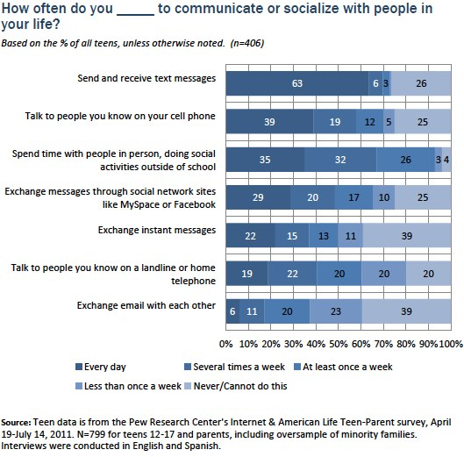
There are many changes happening to a child as they move through adolescence. Puberty and that grumpy, "mean"-ager syndrome, as I like to call it, may be the first thing that comes to mind. Less visible than the physical development, but still representing a major change, is the development of personal identity. As teens start to develop a more consistent sense of self, the necessary separation from parents begins to take place. With this transition to adulthood, comes more independence for the teens and the question of how much should parents manage their child's activities. Cell phones have become an integral part of kid's daily lives and a major way they communicate with people in their lives, not just their friends (Figure 1). In this age of online dangers, how much privacy should parents give to their children in these activities?
Figure 1: Teens Communication Methods
Source: Pew Research Center. Web. 08 Apr 2015.
Businesses profile web requests, friends monitor posts on social media, and even strangers can engage the youngsters in a chat room anonymously, but parents can be the last to know about their children's online activities. Predators spend time trolling social networking sites looking for information and people to target for exploitation. Over-sharing personal information on social networking sites is common and teens can unknowingly interact with an online predator. John Whitaker, special agent in charge of GBI's Child Exploitation and Computer Crimes Unit says, "Child predators have worked their language down to an art on how to approach children who don't think anybody else cares about their problems or wants to spend time with them." They gradually seduce their targets through attention, affection, kindness, and even gifts to ease them into sexual conversations or explicit material. And they may even evaluate the kids they meet online for future face-to-face contact. With all the ups and downs teens are experiencing, it's easy for them to feel they are alone and nobody understands them, which may put them at risk of this kind of contact.
Another online pitfall for teens, in their clumsy attempt to connect with each other, is sexting (sending sexually explicit photographs or messages). With their inability to see the consequences of their actions and lack of personal boundaries, this can be disastrous for teens. Teens that send a nude photo of themselves expecting it to be confidential can find the picture being mass distributed as an act of revenge. In addition to the morally questionable act of sharing the photo without consent, it's actually a crime. These photos are considered child pornography. And for the teen who's photo was shared, comes embarrassment, humiliation, guilt, and shame, which impacts the developing self-esteem and opens them up to bullying.
According to Erik Erikson, a prominent developmental theorist of the 1950's, during middle adolescence youth must resolve a life crisis he calls the crisis of identity versus identity confusion. This crisis represents the struggle to find a balance between developing a unique, individual identity while still being accepted and "fitting in." While teens are learning what makes them unique, they also have an increased need to fit in. Teens may take advantage of this opportunity to bully others in an attempt to help them fit in with their peers or help them cope with their own low self-esteem. Teens engaging in cyberbullying can receive a misdemeanor cyberharassment charge or a juvenile delinquency charge. And for the teen being cyberbullied there is a higher risk of depression and anxiety. They are more likely to struggle personally feeling isolated, alone, excluded, ostracized and can lead to thoughts about suicide. In addition, their friends may distance themselves for fear they will also be bullied resulting in loss of friendships and support.
Additional dangers lurk in the dark, hard to reach corners of the internet, or so we might think. According to the Department of Justice, "Never before in the history of telecommunications media in the United States has so much indecent (and obscene) material been so easily accessible by so many minors in so many American homes with so few restrictions". Pornography is a definite danger to our children. Some of the latest reports are showing that seven out of ten youth have accidentally come across pornography online. The hormones and neurotransmitters that are activated during the viewing of pornography brings them back for more. This is harmful to the brain's sexual development, in which billions of new synaptic connections are made. It can be intimidating when comparing themselves with the bodies they are seeing, and can lead to shame about their own body. It paints an unrealistic picture of sexuality and relationships, as may result in failure to be aroused by the bodies of others. The viewer is being wired to expect that sex and relationships are separate from one another. While masturbating to porn the teen's brain is being bonded to a pornographic experience void of any love or compassion, instead of a deep connection to another person. It can also lead to problems in sexual compulsivity and sex addiction. All of which can change how the teen feels about and sees themselves.
If or, should I say when, teens are faced with these online dangers, they may not be willing to share it with an adult. They may fear judgment or punishment from adults like having their phone privileges being revoked. Even more troubling is that they may not recognize the danger, or may want to handle it on their own.
The many far reaching consequences of these activities can be minimized if parents are monitoring these interactions and continuing open communication with their teens about these dangers. Privacy is a hot commodity to teens, but personally I believe that privacy should be earned through demonstrating good judgment and the amount of honesty they are showing. Each parent will need to determine where that line is. As parents, it's our responsibility to see around corners and protect them, if nothing else, from themselves. And at least until we can see our children able to do this for themselves, I'm not so sure three is a crowd.

